**NSDE Programming ASSIGNMENT 3**

Name: Keerti P. Charantimath Roll Number: 19MA20059

**Q1.**

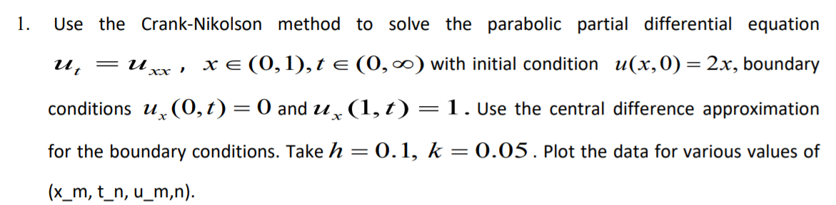

**Matlab Code:**

|  |
| --- |
| u_t_0 = @(x) 2*x;  ux_x_0 = @(t) 0;  ux_x_n = @(t) 1;    h=0.1;  k=0.05;    lambda = k / h^2;    x_init = 0;  x_final = 1;  t_init = 0;  t_final = 1;    x_itr = (x_final - x_init) / h;  t_itr = (t_final - t_init) / k;    Values = zeros(x_itr + 1, t_itr + 1);    for i=1:x_itr + 1  Values(i, 1) = u_t_0(x_init + h * (i-1));  end    A = zeros(x_itr + 1, x_itr + 1);  B = zeros(x_itr + 1, 1);    syms u_m1_n2 u_m2_n2 u_m3_n2 u_m1_n1 u_m2_n1 u_m3_n1 eq  eq(u_m1_n2, u_m2_n2, u_m3_n2, u_m1_n1, u_m2_n1, u_m3_n1) = -1 * lambda * u_m1_n2 + (2 + 2 * lambda) * u_m2_n2 - (lambda) * u_m3_n2 - 1 * lambda * u_m1_n1 - (2 - 2 * lambda) * u_m2_n1 - lambda * u_m3_n1;    for j=1:t_itr  for i=1:x_itr + 1  if i==1  temp_eqs = subs(eq, {u_m1_n2 u_m1_n1}, {u_m3_n2 u_m3_n1});  temp_val = subs(eq, {u_m1_n2 u_m2_n2 u_m3_n2 u_m1_n1 u_m2_n1 u_m3_n1}, {0 0 0 0 0 0});    A(1, 1) = subs(temp_eqs, {u_m2_n2 u_m3_n2 u_m2_n1 u_m3_n1}, {1 0 0 0}) - temp_val;  A(1, 2) = subs(temp_eqs, {u_m2_n2 u_m3_n2 u_m2_n1 u_m3_n1}, {0 1 0 0}) - temp_val;  % B(1, 1) = subs(temp_rhs, {u_m2_n1 u_m3_n1}, {Values(1, j) Values(2, j)});  B(1, 1) = -1 * (subs(temp_eqs, {u_m2_n2 u_m3_n2 u_m2_n1 u_m3_n1}, {0 0 Values(1, j) Values(2, j)}) - temp_val);    elseif i == x_itr + 1  temp_eqs = subs(eq, {u_m3_n2 u_m3_n1}, {0.2 + u_m1_n2 0.2 + u_m1_n1});  temp_val = subs(eq, {u_m1_n2 u_m2_n2 u_m3_n2 u_m1_n1 u_m2_n1 u_m3_n1}, {0 0 0 0 0 0});    A(x_itr + 1, x_itr) = subs(temp_eqs, {u_m1_n2 u_m2_n2 u_m1_n1 u_m2_n1}, {1 0 0 0}) - temp_val;  A(x_itr + 1, x_itr + 1) = subs(temp_eqs, {u_m1_n2 u_m2_n2 u_m1_n1 u_m2_n1}, {0 1 0 0}) - temp_val;  B(x_itr + 1, 1) = -1 * (subs(temp_eqs, {u_m1_n1 u_m2_n1 u_m1_n2 u_m2_n2}, {Values(x_itr, j) Values(x_itr + 1, j) 0 0}) - temp_val);  else  temp_val = subs(eq, {u_m1_n2 u_m2_n2 u_m3_n2 u_m1_n1 u_m2_n1 u_m3_n1}, {0 0 0 0 0 0});  A(i, i - 1) = subs(eq, {u_m1_n2 u_m2_n2 u_m3_n2 u_m1_n1 u_m2_n1 u_m3_n1}, {1 0 0 0 0 0}) - temp_val;  A(i, i) = subs(eq, {u_m1_n2 u_m2_n2 u_m3_n2 u_m1_n1 u_m2_n1 u_m3_n1}, {0 1 0 0 0 0}) - temp_val;  A(i, i + 1) = subs(eq, {u_m1_n2 u_m2_n2 u_m3_n2 u_m1_n1 u_m2_n1 u_m3_n1}, {0 0 1 0 0 0}) - temp_val;  % B(i, 1) = subs(eq_rhs, {u_m1_n1 u_m2_n1 u_m3_n1}, {Values(i-1, j) Values(i, j) Values(i + 1, j)});    B(i, 1) = -1 * (subs(eq, {u_m1_n1 u_m2_n1 u_m3_n1 u_m1_n2 u_m2_n2 u_m3_n2}, {Values(i-1, j) Values(i, j) Values(i + 1, j) 0 0 0}) - temp_val);  end  end    Values(:, j+1) = linsolve(A, B);  A = zeros(x_itr + 1, x_itr + 1);  B = zeros(x_itr + 1, 1);  end      X = 0:0.1:1;  T = 0:0.05:1;  surf(X.', T.', Values.')  xlabel('x');  ylabel('t');  zlabel('u'); |

**Table:**

|  |  |  |  |  |  |  |  |
| --- | --- | --- | --- | --- | --- | --- | --- |
| x \ t | 0 | 0.05 | 0.1 | 0.15 | 0.2 | 0.25 | 0.3 |
| 0 | 0 | 0.609275 | 0.704092 | 1.07433 | 1.359187 | 1.848288 | 2.362102 |
| 0.1 | 0.2 | 0.53113 | 0.801201 | 1.051269 | 1.43922 | 1.866076 | 2.447077 |
| 0.2 | 0.4 | 0.585437 | 0.873885 | 1.152659 | 1.549981 | 2.023877 | 2.624439 |
| 0.3 | 0.6 | 0.713919 | 0.987775 | 1.324354 | 1.749367 | 2.282612 | 2.941091 |
| 0.4 | 0.8 | 0.887968 | 1.165639 | 1.566706 | 2.0481 | 2.655298 | 3.407185 |
| 0.5 | 1 | 1.097205 | 1.419383 | 1.893605 | 2.454845 | 3.162851 | 4.039165 |
| 0.6 | 1.2 | 1.345324 | 1.763117 | 2.320204 | 2.986386 | 3.828811 | 4.863265 |
| 0.7 | 1.4 | 1.651573 | 2.215837 | 2.86065 | 3.670552 | 4.679115 | 5.916802 |
| 0.8 | 1.6 | 2.058451 | 2.793635 | 3.533944 | 4.54583 | 5.741733 | 7.253101 |
| 0.9 | 1.8 | 2.648709 | 3.482125 | 4.39267 | 5.640433 | 7.063387 | 8.93491 |
| 1 | 2 | 3.578451 | 4.164499 | 5.62173 | 6.863805 | 8.825453 | 10.92492 |

|  |  |  |  |  |  |  |  |
| --- | --- | --- | --- | --- | --- | --- | --- |
| x \ t | 0.35 | 0.4 | 0.45 | 0.5 | 0.55 | 0.6 | 0.65 |
| 0 | 3.073033 | 3.902421 | 4.972944 | 6.269561 | 7.902193 | 9.907757 | 12.40954 |
| 0.1 | 3.130244 | 4.011087 | 5.078382 | 6.423447 | 8.074834 | 10.13623 | 12.68142 |
| 0.2 | 3.368336 | 4.291211 | 5.439282 | 6.859897 | 8.625466 | 10.81127 | 13.52482 |
| 0.3 | 3.764695 | 4.782216 | 6.048528 | 7.616246 | 9.562425 | 11.9743 | 14.96564 |
| 0.4 | 4.341055 | 5.500229 | 6.93729 | 8.720165 | 10.93029 | 13.67118 | 17.06915 |
| 0.5 | 5.125076 | 6.47425 | 8.14487 | 10.21842 | 12.78786 | 15.9747 | 19.9252 |
| 0.6 | 6.151343 | 7.745695 | 9.723273 | 12.17527 | 15.21462 | 18.98378 | 23.6559 |
| 0.7 | 7.463403 | 9.369088 | 11.74076 | 14.67383 | 18.31541 | 22.82649 | 28.42182 |
| 0.8 | 9.111342 | 11.41888 | 14.28052 | 17.82335 | 22.22187 | 27.66796 | 34.42711 |
| 0.9 | 11.15707 | 13.99389 | 17.43971 | 21.77056 | 27.09004 | 33.72616 | 41.91932 |
| 1 | 13.78346 | 17.12297 | 21.42317 | 26.62585 | 33.17793 | 41.21909 | 51.25408 |

|  |  |  |  |  |  |  |  |
| --- | --- | --- | --- | --- | --- | --- | --- |
| x \ t | 0.7 | 0.75 | 0.8 | 0.85 | 0.9 | 0.95 | 1 |
| 0 | 15.49978 | 19.34055 | 24.09519 | 29.99598 | 37.30735 | 46.37583 | 57.61623 |
| 0.1 | 15.84594 | 19.76254 | 24.62413 | 30.6472 | 38.1184 | 47.37847 | 58.86166 |
| 0.2 | 16.88641 | 21.05686 | 26.22537 | 32.63535 | 40.58101 | 50.43359 | 62.6479 |
| 0.3 | 18.67408 | 23.27216 | 28.97304 | 36.04105 | 44.80433 | 55.66903 | 69.13955 |
| 0.4 | 21.28244 | 26.50601 | 32.98252 | 41.01215 | 50.96756 | 63.31043 | 78.61343 |
| 0.5 | 24.82357 | 30.89651 | 38.42595 | 47.76115 | 59.33505 | 73.68473 | 91.47563 |
| 0.6 | 29.4494 | 36.63149 | 45.53667 | 56.57694 | 70.26532 | 87.23611 | 108.2771 |
| 0.7 | 35.35741 | 43.95713 | 54.61882 | 67.83741 | 84.22626 | 104.5451 | 129.7373 |
| 0.8 | 42.80029 | 53.18778 | 66.06061 | 82.02566 | 101.815 | 126.354 | 156.7746 |
| 0.9 | 52.10552 | 64.71108 | 80.3589 | 99.74345 | 123.7898 | 153.5922 | 190.5507 |
| 1 | 63.64268 | 79.04467 | 98.10602 | 121.7662 | 151.0783 | 187.4379 | 232.5027 |

**Graph:**

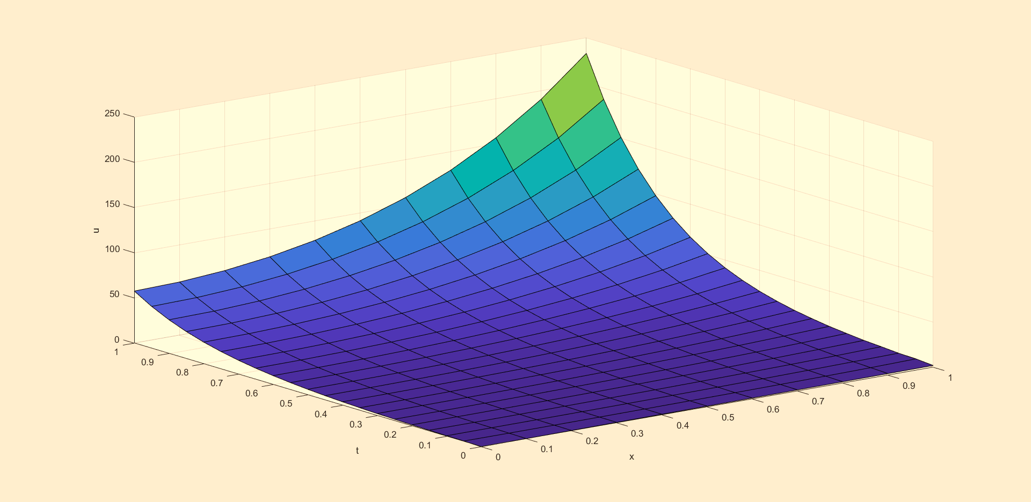

**Q2.**

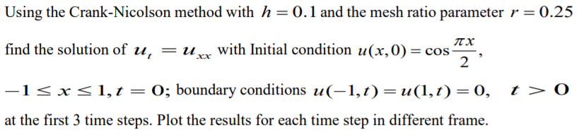

**Matlab Code:**

|  |
| --- |
| u_t_0 = @(x) cos(pi * x / 2);  ux_x_0 = @(t) 0;  ux_x_n = @(t) 0;    h=0.1;  lambda = 0.25;  k=lambda * h^2;    x_init = -1;  x_final = 1;  t_init = 0;  t_final = 0.0075;    x_itr = int16((x_final - x_init) / h);  t_itr = int16((t_final - t_init) / k);  Values = zeros(x_itr + 1, t_itr + 1);    for i=1:x_itr + 1  Values(i, 1) = u_t_0(x_init + h * double(i-1));  end    for j=2:t_itr + 1  Values(1, j) = 0;  Values(x_itr + 1, j) = 0;  end    A = zeros(x_itr - 1, x_itr - 1);  B = zeros(x_itr - 1, 1);    syms u_m1_n2 u_m2_n2 u_m3_n2 u_m1_n1 u_m2_n1 u_m3_n1 eq  eq(u_m1_n2, u_m2_n2, u_m3_n2, u_m1_n1, u_m2_n1, u_m3_n1) = -1 * lambda * u_m1_n2 + (2 + 2 * lambda) * u_m2_n2 - (lambda) * u_m3_n2 - 1 * lambda * u_m1_n1 - (2 - 2 * lambda) * u_m2_n1 - lambda * u_m3_n1;    for j=1:t_itr  for i=2:x_itr  if i == 2  temp_eqs = subs(eq, {u_m1_n2 u_m1_n1}, {Values(1, j+1) Values(1, j)});  temp_val = subs(temp_eqs, {u_m2_n2 u_m3_n2 u_m2_n1 u_m3_n1}, {0 0 0 0});    A(1, 1) = subs(temp_eqs, {u_m2_n2 u_m3_n2 u_m2_n1 u_m3_n1}, {1 0 0 0}) - temp_val;  A(1, 2) = subs(temp_eqs, {u_m2_n2 u_m3_n2 u_m2_n1 u_m3_n1}, {0 1 0 0}) - temp_val;  % B(1, 1) = subs(temp_rhs, {u_m2_n1 u_m3_n1}, {Values(1, j) Values(2, j)});  B(1, 1) = -1 * (subs(temp_eqs, {u_m2_n2 u_m3_n2 u_m2_n1 u_m3_n1}, {0 0 Values(2, j) Values(3, j)}) - temp_val);    elseif i == x_itr  temp_eqs = subs(eq, {u_m3_n2 u_m3_n1}, {Values(x_itr + 1, j + 1) Values(x_itr + 1, j)});  temp_val = subs(temp_eqs, {u_m1_n2 u_m2_n2 u_m1_n1 u_m2_n1}, {0 0 0 0});    A(x_itr - 1, x_itr - 2) = subs(temp_eqs, {u_m1_n2 u_m2_n2 u_m1_n1 u_m2_n1}, {1 0 0 0}) - temp_val;  A(x_itr - 1, x_itr - 1) = subs(temp_eqs, {u_m1_n2 u_m2_n2 u_m1_n1 u_m2_n1}, {0 1 0 0}) - temp_val;  B(x_itr - 1, 1) = -1 * (subs(temp_eqs, {u_m1_n1 u_m2_n1 u_m1_n2 u_m2_n2}, {Values(x_itr - 1, j) Values(x_itr, j) 0 0}) - temp_val);  else  temp_val = subs(eq, {u_m1_n2 u_m2_n2 u_m3_n2 u_m1_n1 u_m2_n1 u_m3_n1}, {0 0 0 0 0 0});    A(i - 1, i - 2) = subs(eq, {u_m1_n2 u_m2_n2 u_m3_n2 u_m1_n1 u_m2_n1 u_m3_n1}, {1 0 0 0 0 0}) - temp_val;  A(i - 1, i - 1) = subs(eq, {u_m1_n2 u_m2_n2 u_m3_n2 u_m1_n1 u_m2_n1 u_m3_n1}, {0 1 0 0 0 0}) - temp_val;  A(i - 1, i) = subs(eq, {u_m1_n2 u_m2_n2 u_m3_n2 u_m1_n1 u_m2_n1 u_m3_n1}, {0 0 1 0 0 0}) - temp_val;  % B(i, 1) = subs(eq_rhs, {u_m1_n1 u_m2_n1 u_m3_n1}, {Values(i-1, j) Values(i, j) Values(i + 1, j)});    B(i - 1, 1) = -1 * (subs(eq, {u_m1_n1 u_m2_n1 u_m3_n1 u_m1_n2 u_m2_n2 u_m3_n2}, {Values(i-1, j) Values(i, j) Values(i + 1, j) 0 0 0}) - temp_val);  end  end    Values(2:x_itr, j+1) = linsolve(A, B);  A = zeros(x_itr - 1, x_itr - 1);  B = zeros(x_itr - 1, 1);  end      X = -1:0.1:1  T = 0:0.0025:0.0075  surf(X.', T.', Values.')  xlabel('x');  ylabel('t');  zlabel('u'); |

**Table:**

|  |  |  |  |  |
| --- | --- | --- | --- | --- |
| x \ t | 0 | 0.0025 | 0.005 | 0.0075 |
| -1 | 6.12E-17 | 0 | 0 | 0 |
| -0.9 | 0.156434 | 0.155474 | 0.15452 | 0.153572 |
| -0.8 | 0.309017 | 0.307121 | 0.305236 | 0.303363 |
| -0.7 | 0.45399 | 0.451204 | 0.448435 | 0.445683 |
| -0.6 | 0.587785 | 0.584178 | 0.580593 | 0.57703 |
| -0.5 | 0.707107 | 0.702767 | 0.698454 | 0.694168 |
| -0.4 | 0.809017 | 0.804052 | 0.799118 | 0.794214 |
| -0.3 | 0.891007 | 0.885538 | 0.880104 | 0.874703 |
| -0.2 | 0.951057 | 0.94522 | 0.939419 | 0.933654 |
| -0.1 | 0.987688 | 0.981627 | 0.975603 | 0.969616 |
| 0 | 1 | 0.993863 | 0.987764 | 0.981702 |
| 0.1 | 0.987688 | 0.981627 | 0.975603 | 0.969616 |
| 0.2 | 0.951057 | 0.94522 | 0.939419 | 0.933654 |
| 0.3 | 0.891007 | 0.885538 | 0.880104 | 0.874703 |
| 0.4 | 0.809017 | 0.804052 | 0.799118 | 0.794214 |
| 0.5 | 0.707107 | 0.702767 | 0.698454 | 0.694168 |
| 0.6 | 0.587785 | 0.584178 | 0.580593 | 0.57703 |
| 0.7 | 0.45399 | 0.451204 | 0.448435 | 0.445683 |
| 0.8 | 0.309017 | 0.307121 | 0.305236 | 0.303363 |
| 0.9 | 0.156434 | 0.155474 | 0.15452 | 0.153572 |
| 1 | 6.12E-17 | 0 | 0 | 0 |

**Graph:**

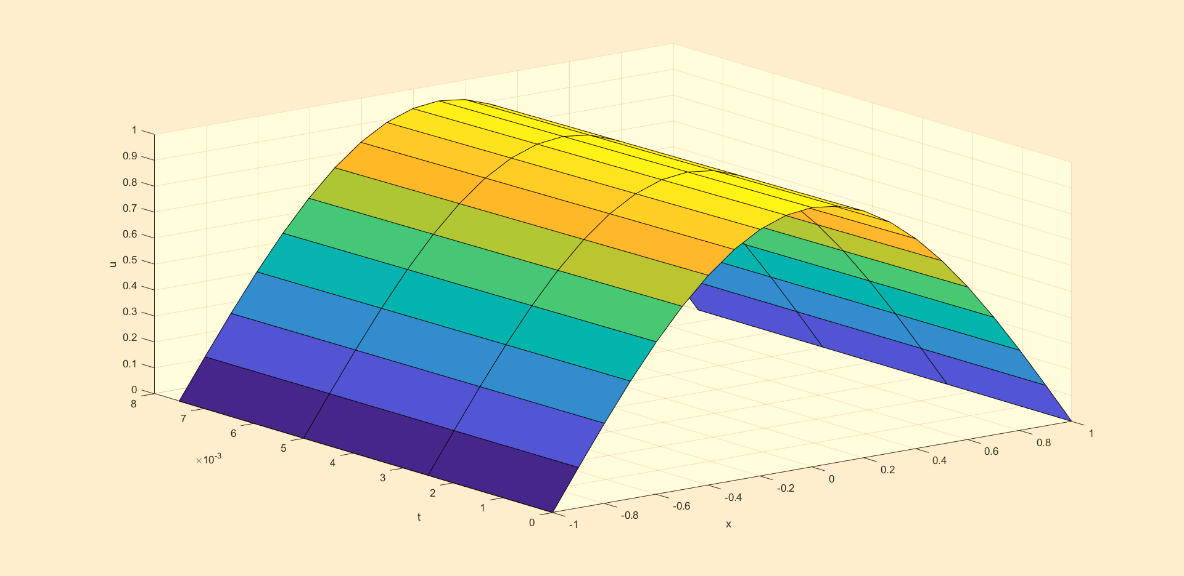

**Q3.** 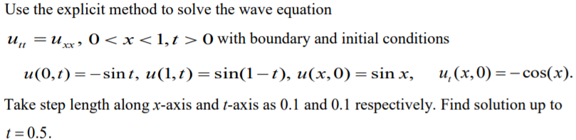

**Matlab Code:**

|  |
| --- |
| f = @(x) sin(x);  g = @(x) -1 * cos(x);    u_x_0 = @(t) -1 * sin(t);  u_x_n = @(t) sin(1 - t);    h=0.1;  k=0.1;  r = 1 * k/h;    x_init = 0;  x_final = 1;  t_init = 0;  t_final = 0.5;    x_itr = int16((x_final - x_init) / h);  t_itr = int16((t_final - t_init) / k);  Values = zeros(x_itr + 1, t_itr + 1);    for i=1:x_itr + 1  Values(i, 1) = f((x_init + h * double(i-1)));  end    for j=1:t_itr + 1  Values(1, j) = u_x_0((t_init + k * double(j-1)));  Values(x_itr + 1, j) = u_x_n((t_init + k * double(j-1)));  end    for i=2:x_itr  Values(i, 2) = 0.5 * (r^2 * f((x_init + double(i - 2) * h)) + 2 * (1 - r^2) * f((x_init + double(i - 1) * h)) + r^2 * f((x_init + double(i) * h)) + 2 * k * g((x_init + double(i - 1) * h)));  end    for j=3:t_itr + 1  for i=2:x_itr  Values(i, j) = r^2 * Values(i-1, j-1) + 2 * (1 - r^2) * Values(i, j-1) + r^2 * Values(i + 1, j-1) - Values(i, j-2);  end  end    X = 0:0.1:1;  T = 0:0.1:0.5;  surf(X.', T.', Values.')  xlabel('x');  ylabel('t');  zlabel('u'); |

**Table:**

|  |  |  |  |  |  |  |
| --- | --- | --- | --- | --- | --- | --- |
| x \ t | 0 | 0.1 | 0.2 | 0.3 | 0.4 | 0.5 |
| 0 | 0 | -0.09983 | -0.19867 | -0.29552 | -0.38942 | -0.47943 |
| 0.1 | 0.099833 | -0.00017 | -0.1 | -0.19883 | -0.29567 | -0.38956 |
| 0.2 | 0.198669 | 0.09967 | -0.00032 | -0.10015 | -0.19897 | -0.29581 |
| 0.3 | 0.29552 | 0.19851 | 0.099517 | -0.00047 | -0.10029 | -0.1991 |
| 0.4 | 0.389418 | 0.295367 | 0.198364 | 0.099379 | -0.0006 | -0.1004 |
| 0.5 | 0.479426 | 0.389272 | 0.295229 | 0.198237 | 0.099263 | -0.0007 |
| 0.6 | 0.564642 | 0.479288 | 0.389145 | 0.295113 | 0.198133 | 0.099263 |
| 0.7 | 0.644218 | 0.564515 | 0.479172 | 0.389041 | 0.295113 | 0.198237 |
| 0.8 | 0.717356 | 0.644102 | 0.564412 | 0.479172 | 0.389145 | 0.295229 |
| 0.9 | 0.783327 | 0.717253 | 0.644102 | 0.564515 | 0.479288 | 0.389272 |
| 1 | 0.841471 | 0.783327 | 0.717356 | 0.644218 | 0.564642 | 0.479426 |

**Graph:**

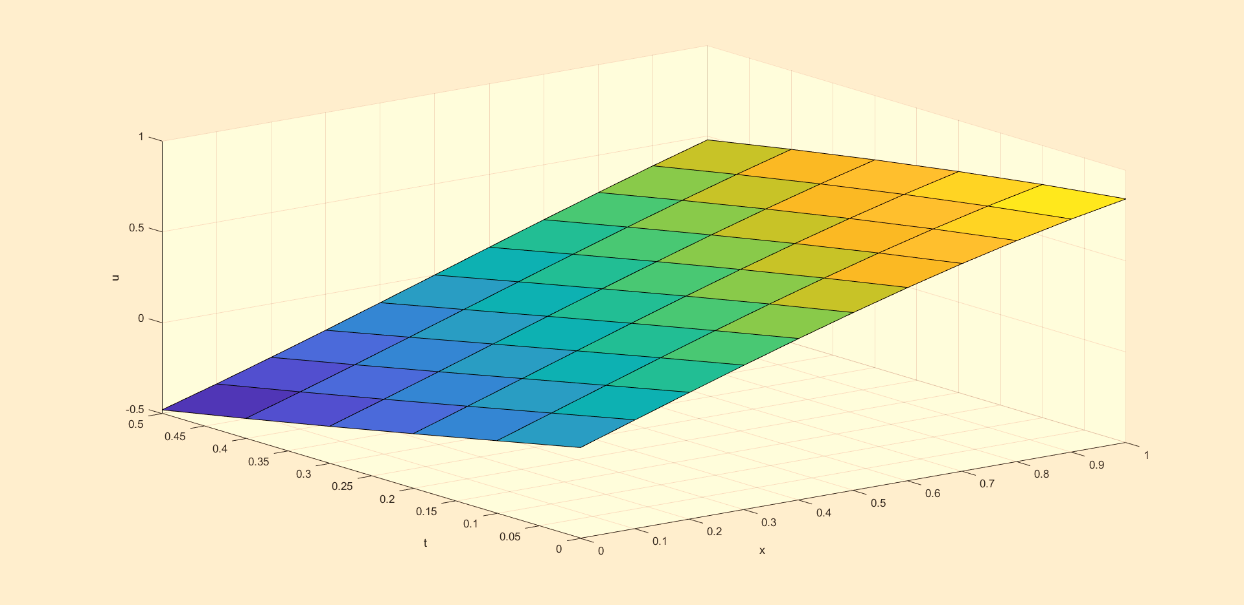

**Q4.** 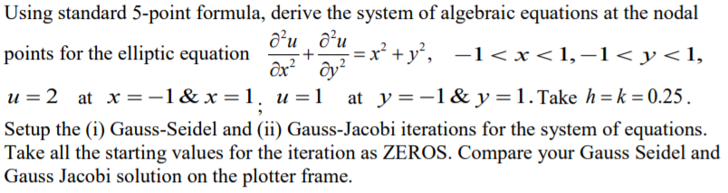

**Matlab Code:**

|  |
| --- |
| h=0.25;  k = 0.25;  iterations = 10;    f = @(x, y) x^2 + y^2;    x_init = -1;  x_final = 1;  y_init = -1;  y_final = 1;    u_x_0 = 2;  u_x_n = 2;  u_y_0 = 1;  u_y_n = 1;    x_itr = int16((x_final - x_init) / h);  y_itr = int16((y_final - y_init) / k);  Values = zeros(x_itr + 1, y_itr + 1);    for i=1:x_itr + 1  Values(i, 1) = u_y_0;  Values(i, y_itr + 1) = u_y_n;  end    for j=1:y_itr + 1  Values(1, j) = u_x_0;  Values(x_itr + 1, j) = u_x_n;  end    Values_jacobi = zeros(x_itr + 1, y_itr + 1);  Values_seidel = zeros(x_itr + 1, y_itr + 1);    Values_jacobi(:, :) = Values(:, :);  Values_seidel(:, :) = Values(:, :);    % Gauss jacobi  for k=1:iterations  Values_temp = zeros(x_itr + 1, y_itr + 1);  Values_temp(:, :) = Values_jacobi(:, :);  for j=2:y_itr  for i=2:x_itr  Values_temp(i, j) = (0.25) * (Values_jacobi(i - 1, j) + Values_jacobi(i + 1, j) + Values_jacobi(i, j-1) + Values_jacobi(i, j+1) - h^2 * f(x_init + h * double(i - 1), y_init + k * double(j - 1)));  end  end    Values_jacobi(:, :) = Values_temp(:, :);  end    % Gauss Seidel  for k=1:iterations  for j=2:y_itr  for i=2:x_itr  Values_seidel(i, j) = (0.25) * (Values_seidel(i - 1, j) + Values_seidel(i + 1, j) + Values_seidel(i, j-1) + Values_seidel(i, j+1) - h^2 * f(x_init + h * double(i - 1), y_init + k * double(j - 1)));  end  end  end    X = -1:0.25:1;  Y = -1:0.25:1;  surf(X.', Y.', Values_jacobi.', 'FaceColor','b', 'FaceAlpha',0.5, 'EdgeColor','none');  hold on  surf(X.', Y.', Values_seidel.', 'FaceColor','g', 'FaceAlpha',0.4, 'EdgeColor','none');  xlabel('x');  ylabel('t');  zlabel('u');  legend('Jacobi', 'Seidel'); |

**Table:**

1. Performing Gauss Jacobi Iterations



1. Performing Gauss Seidel iterations



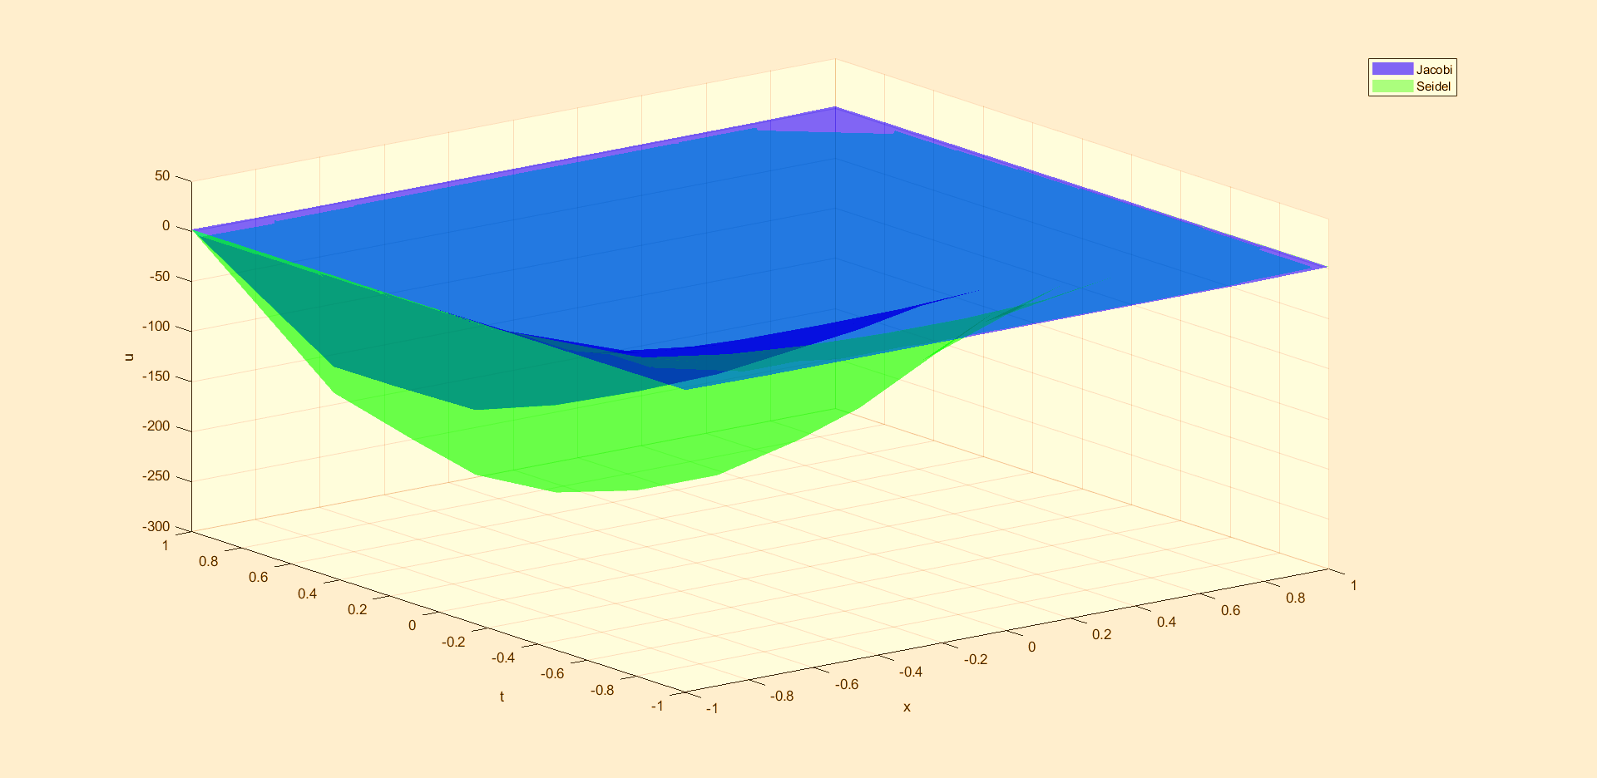**Graph:**